**CYNTHIA CHEPKOECH 146739**

**CHAPTER 4 DIAGRAMS**

**USE CASE DIAGRAM**

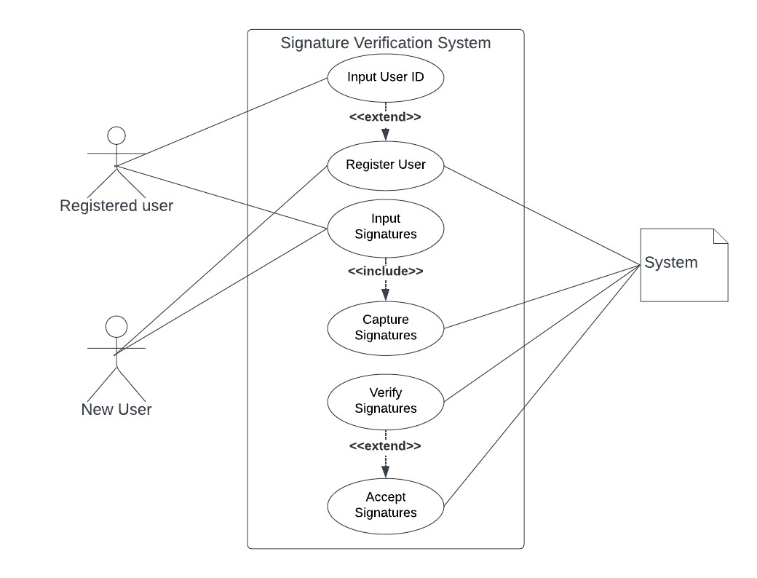

**FLOW CHART DIAGRAM**

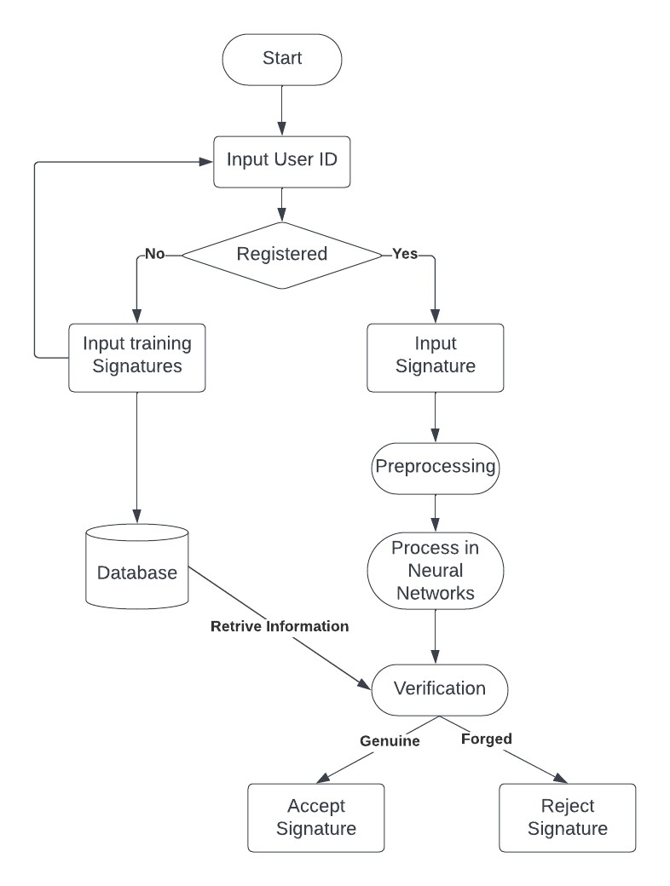

**SEQUENCE DIAGRAM**

**SYSTEM ARCHITECTURE**

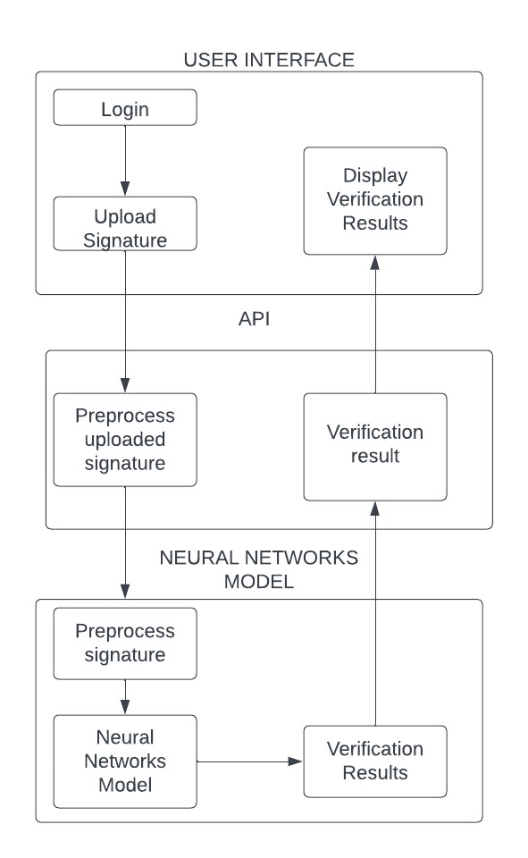

**ERD**

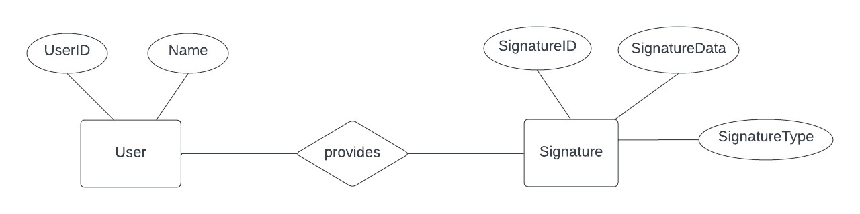

**DATABASE SCHEMA**

